Scoreboard
Instruction Manual

Table of Contents

1 Scoreboard Description 3
1.1 Operation interface 4
1.2 Block Diagram 5

Scoreboard Description
This brief manual describes the functional specification and operation interface of the scoreboard for a FIBA basketball game.
The project will be developed in VHDL using the FPGA Basys 3 architecture and the VGA monitor will act as a scoreboard. A sketch of the scoreboard final visual design is described in Figure 1.1.

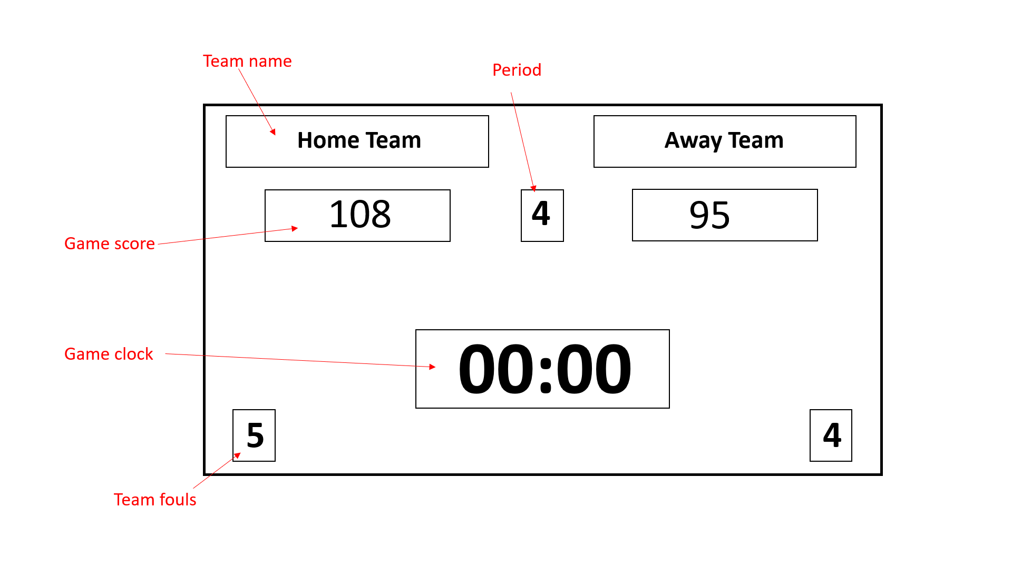
Figure 1.1: Sketch of the scoreboard final visual design

The scoreboard to be developed will follow FIBA regulations and shall contain the following attributes:

- Game clock: digital countdown clock indicating the remaining minutes and seconds that automatic signal the end of the period as soon as it reaches zero.
- Game score: display the score for each time during the game.
- Period: the game consists of 4 periods of 10 minutes each and shall be updated automatically when the game clock reaches 00:00.
- Teams name: the score and team fouls are to be displayed under the respective side of the ‘Home’ and ‘Away’ teams.
- Team fouls: counts up to 5, maximum of fouls that a team can commit until is disqualified.

Operation interface

A keyboard shall be used by an an authorized scorer as an operation interface with the Basys 3 board and the VGA monitor. The game score and team fouls features displayed in the scoreboard will be updated manually and there will be also keyboard keys assigned for the start and reset of the game. Following, it is a brief functional description of those attributes:

Feature |  | Key | Functionality
Game clock |  | ‘Space’ | Start and pause the clock.
 |  | Left ‘Shift’ | Increment the game period
 |  | ‘Del’ | Reset the status of the scoreboard.
Home  Team | Game score | Q | Increment the score by 1.
Home  Team | Game score | A | Decrement the score by 1.
Home  Team | Team fouls | E | Increment the foul by 1.
Home  Team | Team fouls | D | Decrement the foul by 1.
Away  Team | Game score | U | Increment the score by 1.
Away  Team | Game score | J | Decrement the score by 1.
Away  Team | Team fouls | O | Increment the foul by 1.
Away  Team | Team fouls | L | Decrement the foul by 1.
Table 1: Keyboard keys functionalities

The last minute in the 10-minute period shows the seconds and the tenth of the second decrementing in real time.
The square in the VGA screen, related to the team foul functionality, turns red when the team exceeds 5 fouls.
The Figure 1.2 shows this functionality:

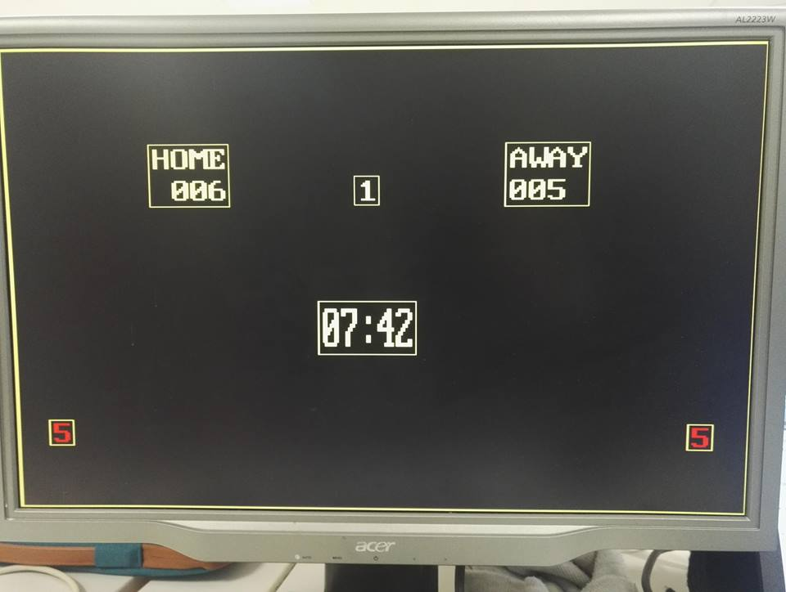
Figure 1.2: Sketch of the scoreboard final visual design

Block Diagram

The RTL diagram is represented in the figure bellow. Following, is the brief description of each entity:
- Keys: this entity implement the functionalities activated by the keys on the keyboard as described in the table 1.
- Vga_syc_unit: a video controller entity that generates the synchronization signals and the timing.
- Font_gen_unit: this entity has the designs for the clock and implements the characters of the ASCII code to be displayed in the VGA screen.
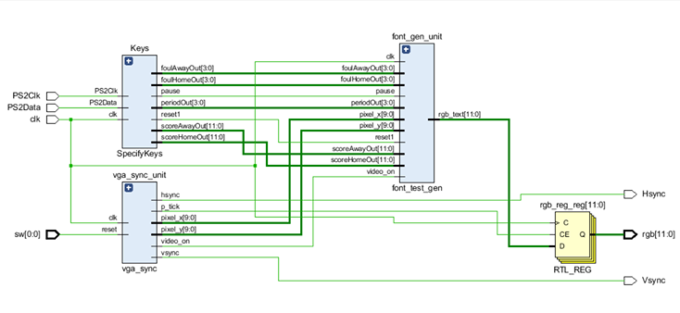
Figure 1.2: Sketch of the scoreboard final visual design

